**System Sequence Diagram:** Turning on a speaker when entering a room

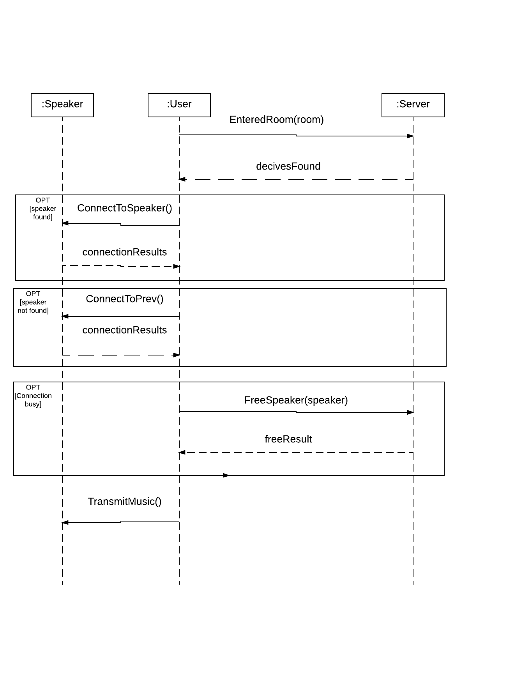

**System Sequence Diagram:** Adding a new speaker to the system

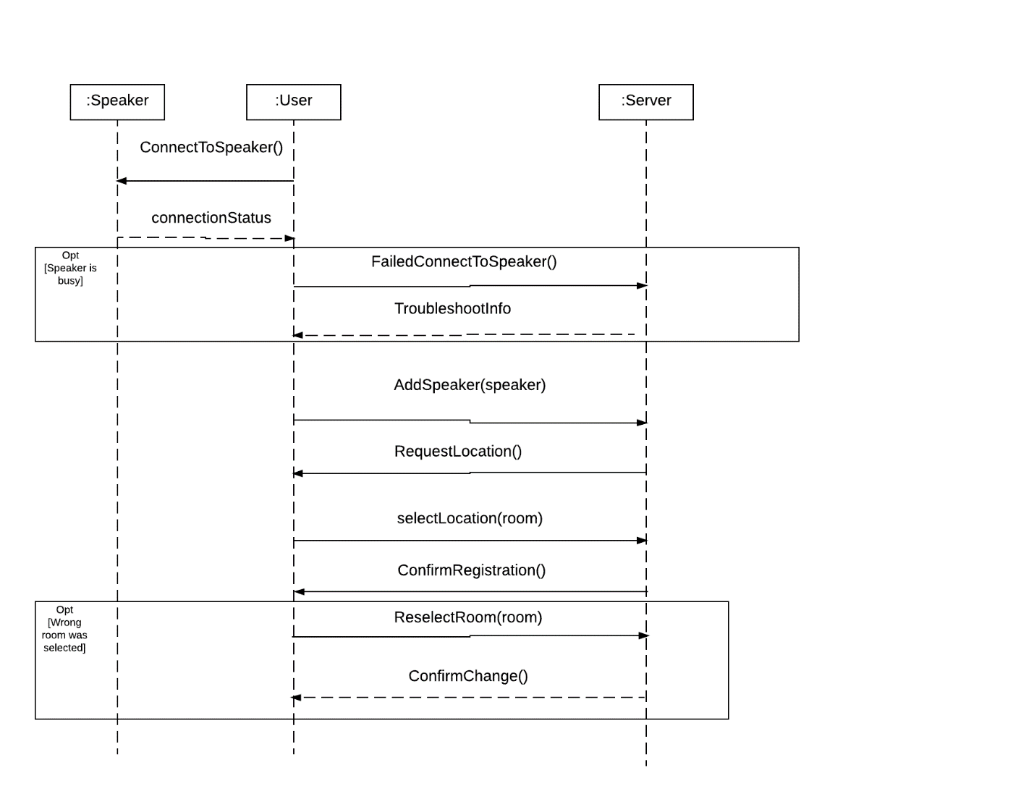

**System Sequence Diagram:** Turning off lights when leaving a room

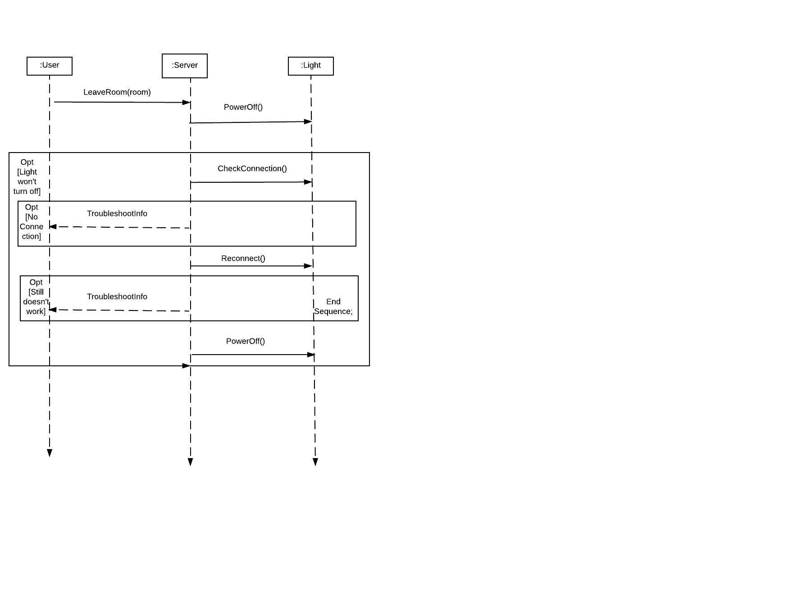

**System Sequence Diagram:** Change Password

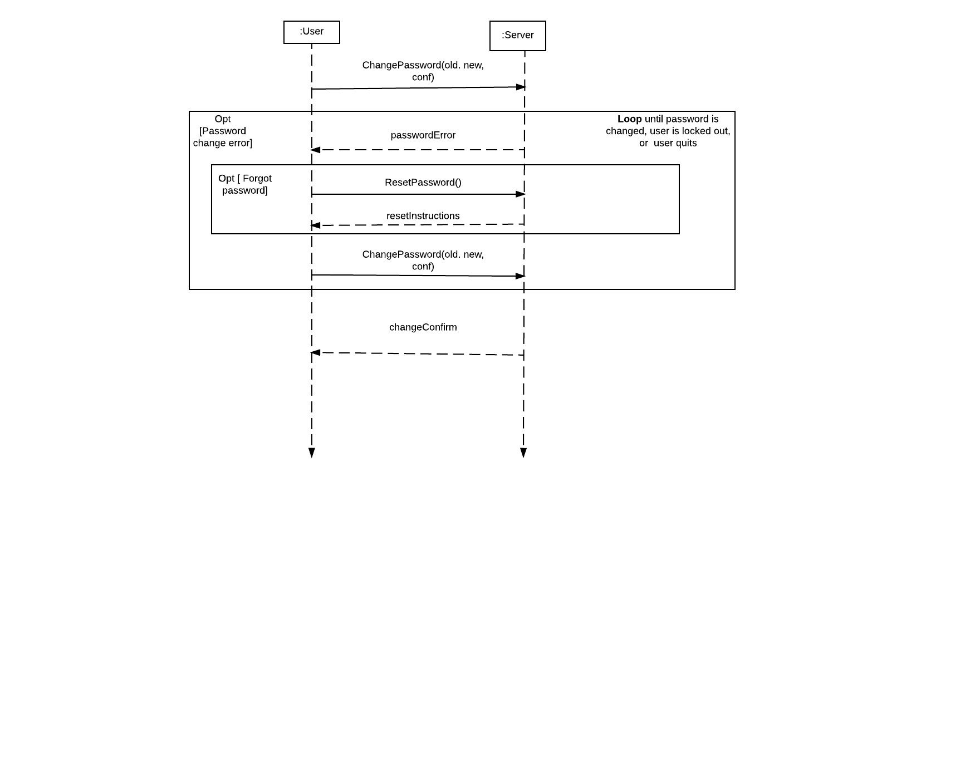

**System Sequence Diagram:** Manually turn lights on and off via Amazon Dash Button

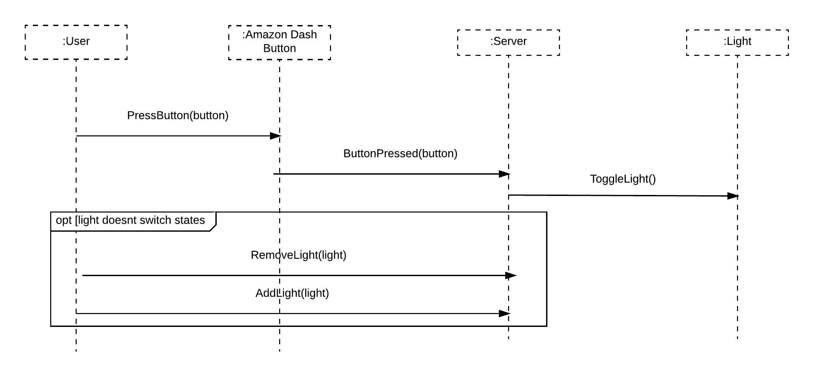

**System Sequence Diagram:** Turn on lights by entering a room

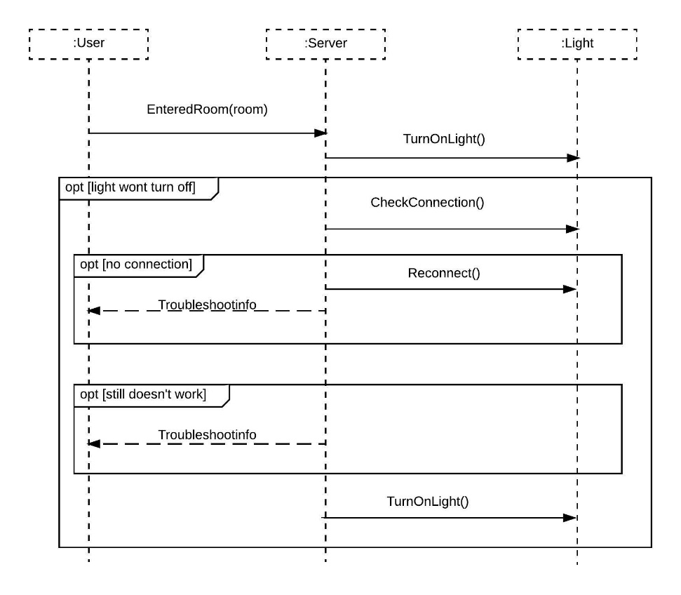

**System Sequence Diagram:** Turn off speaker by leaving a room

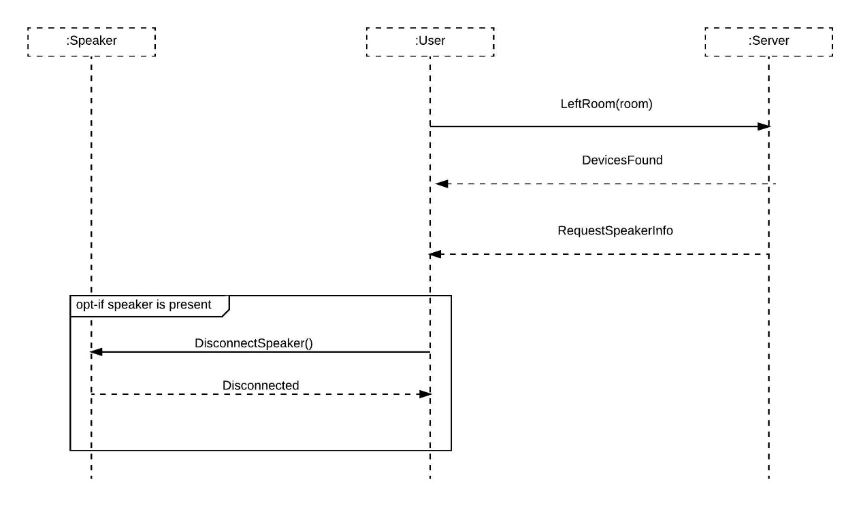

**System Sequence Diagram:** Control brightness of lights via app

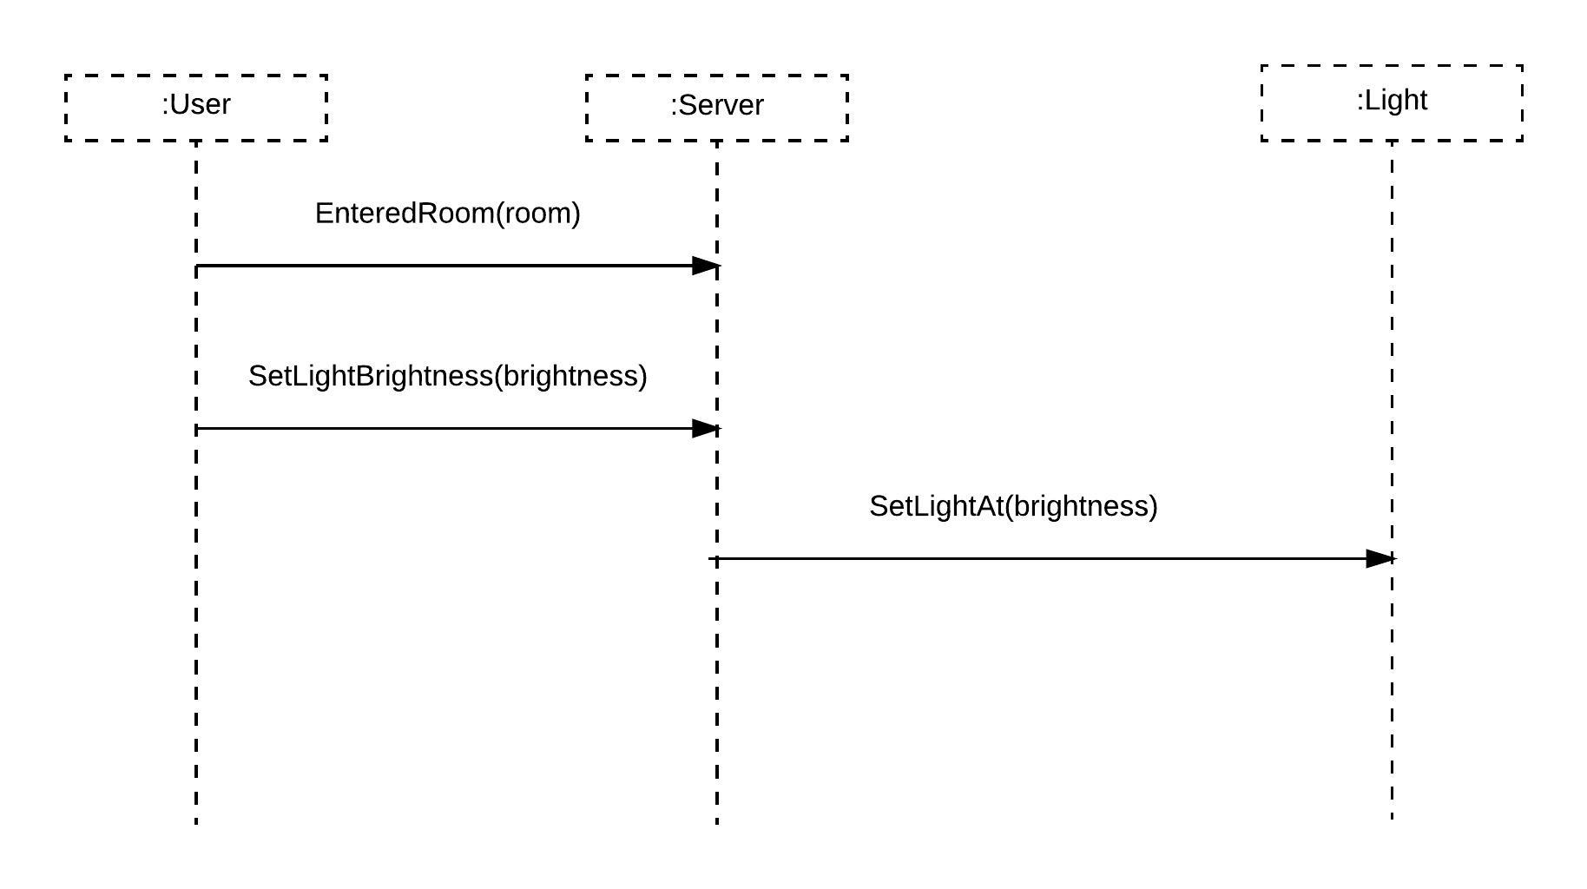

**System Sequence Diagram: Add user:**

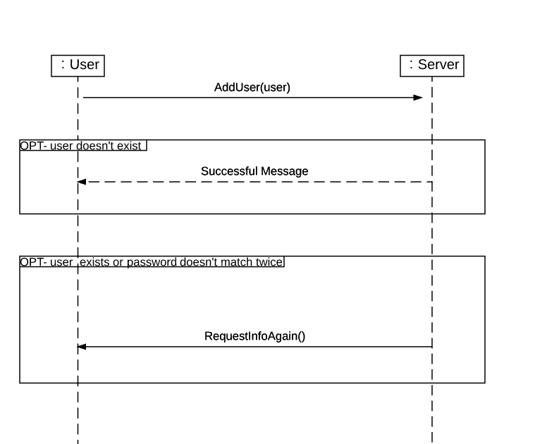

**System Sequence Diagram: Calibrate room boundaries**

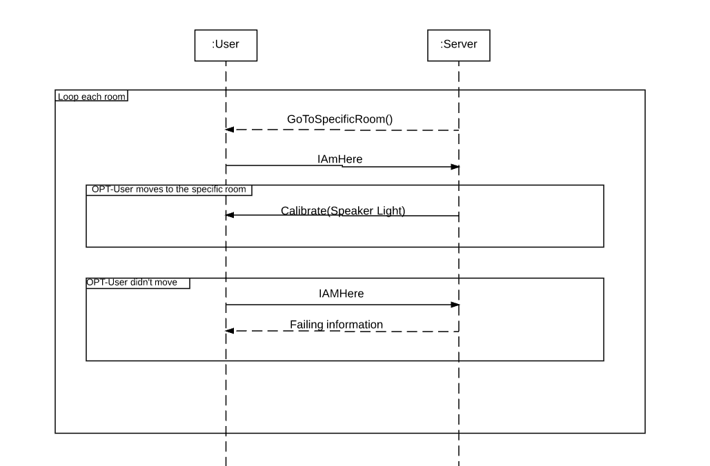

**System Sequence Diagram: Disable/remove speaker**

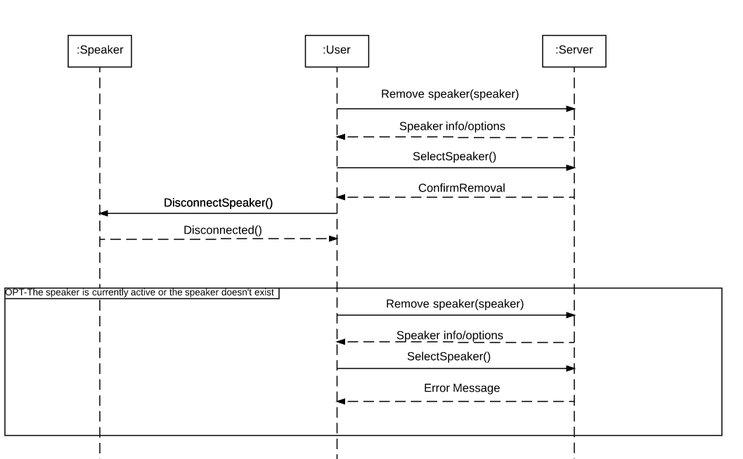

**System Sequence Diagram: Remove user**

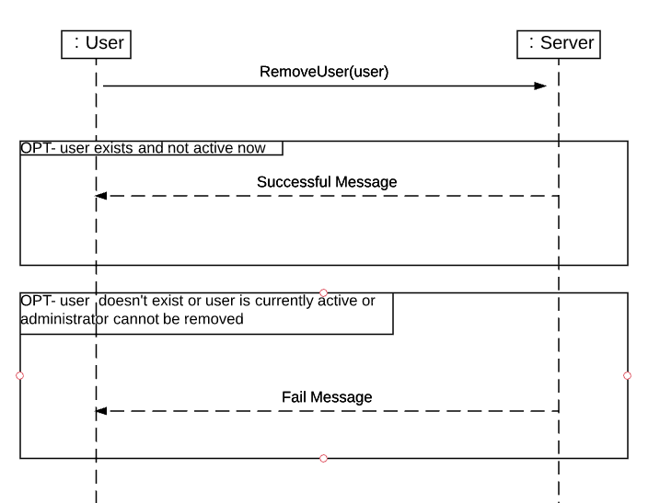

**System Sequence Diagram: Add Dash Button**

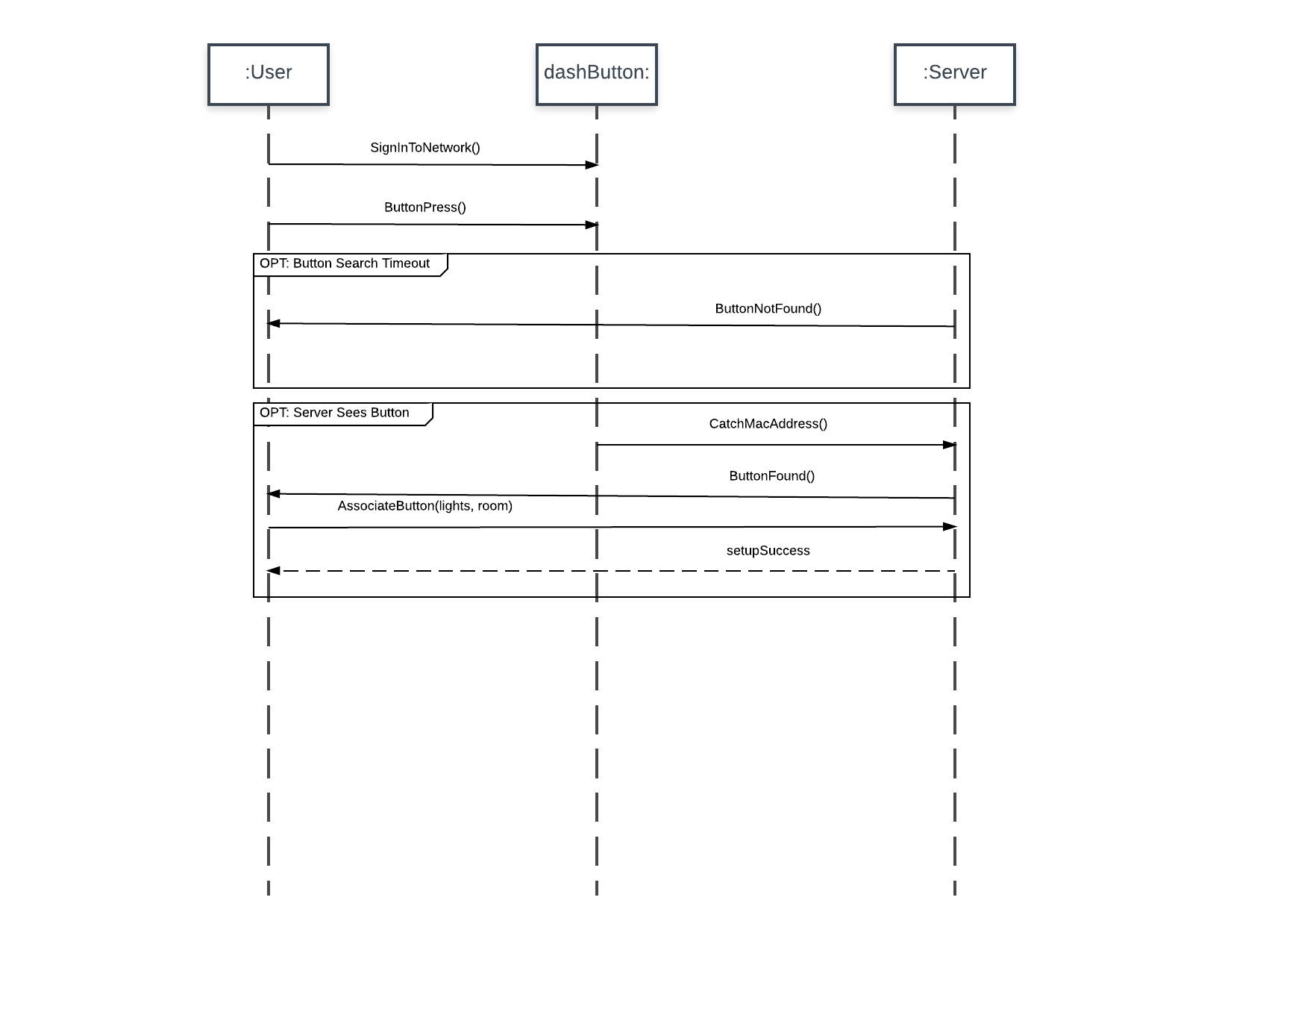

**System Sequence Diagram: Remove Dash Button**

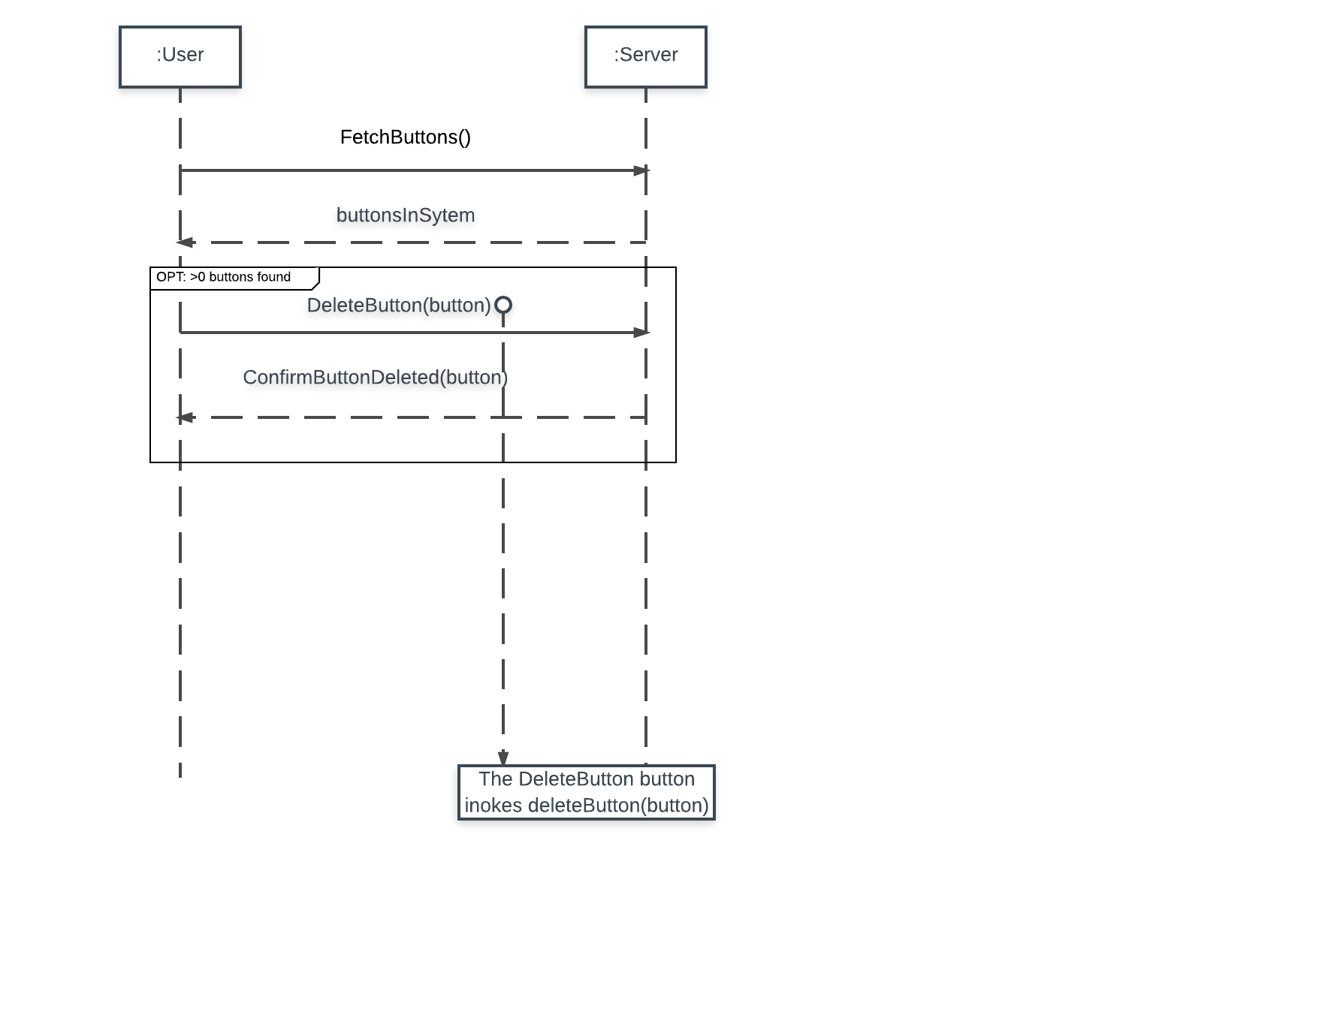

**System Sequence Diagram: Add Light**

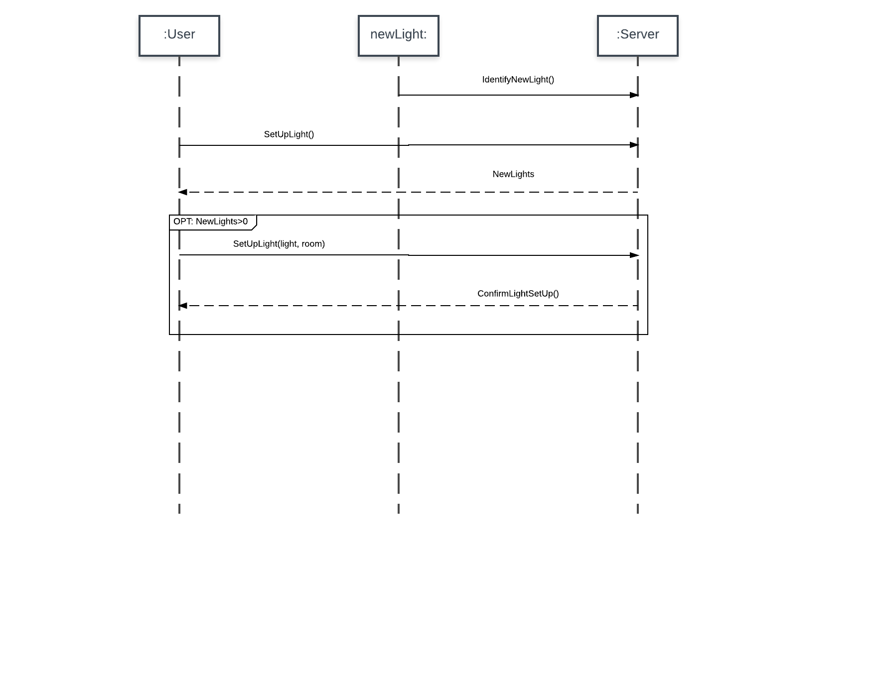

**System Sequence Diagram: Remove Light**

